# **How to Download & Install Apache JMeter in easy steps**

## **Operating system Support for JMeter**

JMeter is a **pure Java** application and should run correctly on any system that has a compatible[Java](https://www.guru99.com/java-tutorial.html)implementation.

Here is the list of an operating system compatible with JMeter

* Linux
* Windows
* Mac OS
* Ubuntu

## **Steps to Install JMeter**

### **Step 1) Install Java**

Because JMeter is pure Java desktop application, it requires a fully compliant JVM 6 or higher. You can download and install the latest version of Java SE Development Kit. [Download Java Platform (JDK)](https://www.oracle.com/java/technologies/javase-downloads.html)

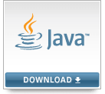

After installation is finished, you can use the following procedure to check whether Java JDK is installed successfully in your system

* In Window/Linux, go to **Terminal**
* Enter command **java -version**

If the Java runtime environment is installed successfully, you will see the output as the figure below

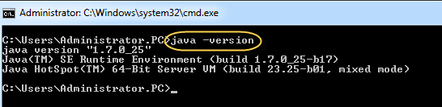

If nothing displays, please re-install Java SE runtime environment

Please see the link for details instructions <https://www.guru99.com/install-java.html>

### **Step 2) Download Jmeter**

As of this writing, the latest version of JMeter is **Apache JMeter 4.2**. You can download it [here](http://jmeter.apache.org/download_jmeter.cgi) But this tutorial demos installation of version 2.9, the install process remains the same.

Choose the Binaries file (either zip or tgz) to download as shown in the figure below

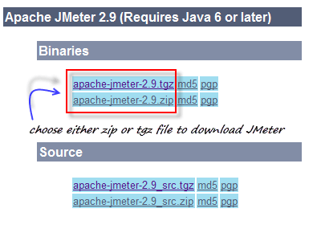

### **Step 3) Installation**

Installation of JMeter is extremely easy and simple. You simply unzip the zip/tar file into the directory where you want JMeter to be installed. There is no tedious installation screen to deal with! Simply unzip and you are done!

Once the unzipping is done installation directory structure should look like as figure below

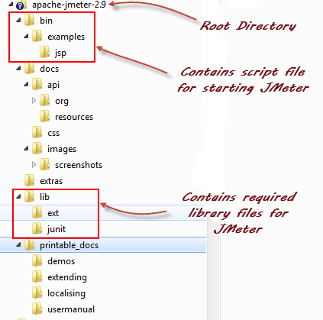

Given below is the description of the JMeter directories and its importance JMeter directory contains many files and directory

* /**bin**: Contains JMeter script file for starting JMeter
* /**docs**: JMeter documentation files
* **/extras**: ant related extra files
* /**lib**/: Contains the required Java library for JMeter
* **/lib/ext**: contains the core jar files for JMeter and the protocols
* **/lib/junit**:[Junit](https://www.guru99.com/junit-tutorial.html)library used for JMeter
* /**printable_docs**:

ADVERTISING

### **Step 4) Launch JMeter**

You can start JMeter in 3 modes

* GUI Mode
* Server Mode
* Command Line Mode

## **Start JMeter in GUI Mode**

If you are using Window, just run the file **/bin/jmeter.bat** to start JMeter in GUI mode as shown below

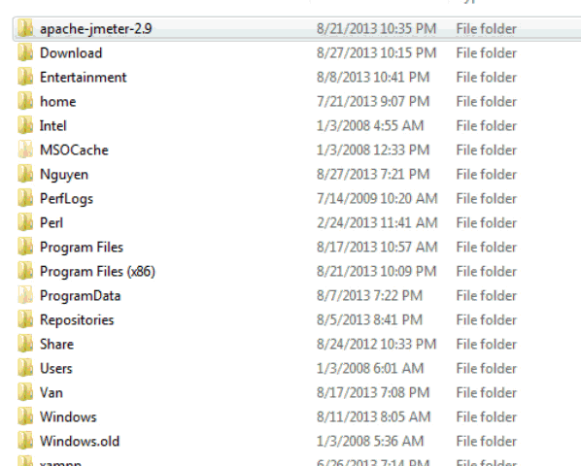

The following figure annotates the various components in the JMeter GUI

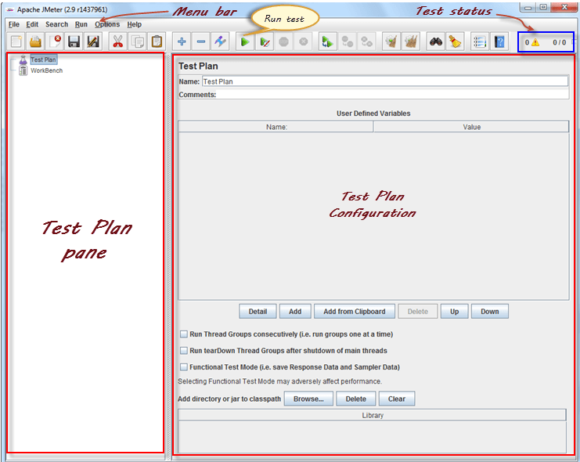

## **How to run JMeter in Non-GUI Mode**

### **Start JMeter in Server Mode**

Server mode is used for **distributed** testing. This[Testing](https://www.guru99.com/software-testing.html)works as **a client-server** model. In this model, JMeter runs on a server computer in **server**mode. On a client computer, JMeter runs in **GUI** mode.

To start the server mode, you run the bat file bin\**jmeter-server.bat**as below figure

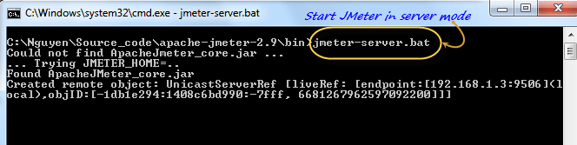

### **Start JMeter in command line mode**

JMeter in GUI mode consumes much computer memory. For saving the resource, you may choose to run JMeter without the GUI. To do so, use the following command options

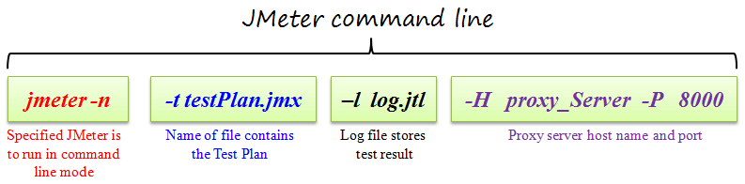

This is a command line example

$jmeter -n -t testPlan.jmx - l log.jtl -H 127.0.0.1 -P 8000

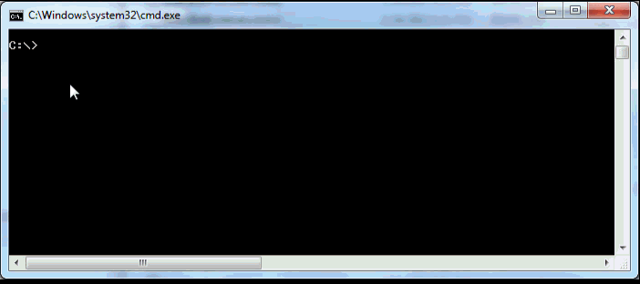

## **Additional Packages**

Based on your requirement, you will need one or more optional packages listed below.

* **Java Compiler**

Java Compiler allows developers to build JMeter source code and other JMeter plugins

* **SAX XML parser**

[SAX](http://www.saxproject.org/) is the Simple API for XML, originally a Java-only API. You can use SAX XML parser as an alternative to XML parser in JMeter

* **Email Support**

JMeter has extensive Email capabilities. It can send email based on test results and has a POP3(S)/IMAP(S) sampler. It also has an SMTP sampler.

* **JDBC driver**

If you want to test database server, you have to install JDBC driver

## **Use JMeter in Linux**

* Using JMeter in[Linux](https://www.guru99.com/unix-linux-tutorial.html)is the same as in Window; you simply run the following [shell script](https://www.guru99.com/introduction-to-shell-scripting.html).
* Run the script file **jmeter** (This file has no extension)- run JMeter (in GUI mode by default).
* Run the script file **jmeter-server** – start JMeter in server mode (calls JMeter script with appropriate parameters)
* **jmeter.sh** – very basic JMeter script with no JVM options specified.
* **mirror-server.sh** – runs the JMeter Mirror Server in non-GUI mode
* **shutdown.sh** – Run the Shutdown client to stop a non-GUI instance gracefully
* **stoptest.sh** – Run the Shutdown client to stop a non-GUI instance abruptly